THE FUTURE PRESIDENT
Twitter turns out to be the deciding factor
SHRADHA SHIWANI – CS DEPARTMENT

WORDS! WORDS! WORDS! What we speak can actually make you the president of your country. There is a lot to share on social networking sites and what you share or else you can say “tweet” in today`s world can make people decide between good or bad. Words do matter, positive or negative and they could be a deciding factor that people want to see you as a leader or a loser.

Introduction
With the advancement in technology, communication has grown. It is now easier and cheap to communicate and connect with people across the world. The issue of distance is no longer an excuse for lack of communication. Communication systems have grown from wired devices to wireless devices. The internet has also brought adverse changes in the forms of communications that are available and currently being used. It has led the rise of social networks. Here you can communicate and share your thoughts with many people at the same time. It is easy to share information like pictures, advertisements, videos and text messages. To many people, it is perceived as a form of entertainment. However, being in social sites enhances communication. There are many types of social sites and it is on oneself to choose the one that they are comfortable with.

Over 50% of people learn about breaking news on social media. 65% of traditional media reporters and editors use sites like Facebook and LinkedIn for story research, and 52% use Twitter. Social networking sites are the top news source for 27.8% of Americans, ranking close to newspapers (28.8%) and above radio (18.8%) and other print publications (6%). Twitter and YouTube users reported the July 20, 2012 Aurora, CO theater shooting before news crews could arrive on the scene, and the Red Cross urged witnesses to tell family members they were safe via social media outlets. Twitter has long argued that its reach and influence extends far beyond the 320 million people who log into its social media service at least once a month. Tweets are embedded on thousands of other websites and apps, emailed, displayed on television and published in newspapers.

Taking popularity into account, Twitter is the determining part of our survey to decide the winner and the best spokesperson among the presidential candidates for United States of America. Our survey focuses on the tweets made by the presidential candidates on twitter, taking nouns into account from their tweets and comparing them with our pool of positive and negative words and deciding the best spokesperson on the basis of which candidate is more on the positive side and which one is more on the negative side, which eventually decides the winner of the presidential election. That goes with our subtitle “Twitter turns out to be the deciding factor”.

Background analysis

Our main aspect revolves around the very popular term these days known as “Big Data” or one can say “Data Mining” as its bigger picture. Big data is everywhere we look these days. Businesses are falling all over themselves to hire 'data scientists,' privacy advocates are concerned about personal data and control, and technologists and entrepreneurs scramble to find new ways to collect, control and monetize data. We know that data is powerful and valuable.

Generally, data mining (sometimes called data or knowledge discovery) is the process of analyzing data from different perspectives and summarizing it into useful information - information that can be used to increase revenue, cuts costs, or both. Data mining software is one of a number of analytical tools for analyzing data. It allows users to analyze data from many different dimensions or angles, categorize it, and summarize the relationships identified. Technically, data mining is the process of finding correlations or patterns among dozens of fields in large relational databases.

Another important feature we have used in our research is R Programming. R is rapidly becoming the leading language in data science and statistics. Today, the R programming language is the tool of choice for data scientists in every industry and field. Whether you are a full-time number cruncher, or just the occasional data analyst, R will suit your needs. R is a programming language and software environment for statistical computing and graphics supported by the R Foundation for Statistical Computing. The R language is widely used among statisticians and data miners for developing statistical software and data analysis. Polls, surveys of data miners, and studies of scholarly literature databases show that R's popularity has increased substantially in recent years.

R and its libraries implement a wide variety of statistical and graphical techniques, including linear and nonlinear modeling, classical statistical tests, time-series analysis, classification, clustering, and others. R is easily extensible through functions and extensions, and the R community is noted for its active contributions in terms of packages. Many of R's standard functions are written in R itself, which makes it easy for users to follow the algorithmic choices made. For computationally intensive tasks, C, C++, and FORTRAN code can be linked and called at run time. Advanced users can write C, C++, Java, .NET or Python code to manipulate R objects directly.

DEFINING THE PROBLEM

So, the task ahead of us was to mine data from twitter which is actually a huge database in itself and analyzing (i.e. filtering) it under the criteria set by us. There are few candidates for the presidential election of United States, which we think are the most deserving ones based on our research, are being selected by us on whom we have performed this survey through the computer program we have developed. The main idea is based on scrutinizing the twitter accounts and tweets of the candidates, which they have made recently and running them through a set of operations, filtering and comparing the words used in the tweets with the pool of positive and negative words made by us, and thus declaring who has appointed more positivity or negativity in his/her social communication and therefore choosing the winner among them on the basis that whoever is more on the good side.

DETAILED ANALYSIS
Entire project is being programmed in R using R Studio as the developing tool. It includes functionalities such as data collection, gathering and filtering data, data processing and graphical representation of the processed data.
Twitter accounts of the respective candidates are located and words are collected from their recent 500 tweets which they have made (actually this number can be changed to any by changing the value of the variable in the code). The words collected are being saved into files known as “Data Files”, each candidate having a separate file saved on the system.
As we run the next part of the code, data files of respective candidates are processed and filtered, filtering the basic words with actual meaning apart from the bluff words i.e. helping verbs, adjectives etc. The tweets are processed on the basis of their connotations. If a candidate tweets positively, the code runs a scan on the written sentence and evaluates each word as positive or negative.
The words before being categorized as positive or negative are actually compared with an inbuilt files containing positive and negative words separately. These inbuilt files are made and saved by us on the system, based on our research on the most basic positive and negative words from the dictionary. The program accordingly stores the result in an output file; each candidate has a separate file.
The code also keeps the track of the most common words being used by the respective candidates in their tweets. The code does this by presenting a visual representation of the most common words being used as a word cloud, saving it in an image file on the system shown as below.
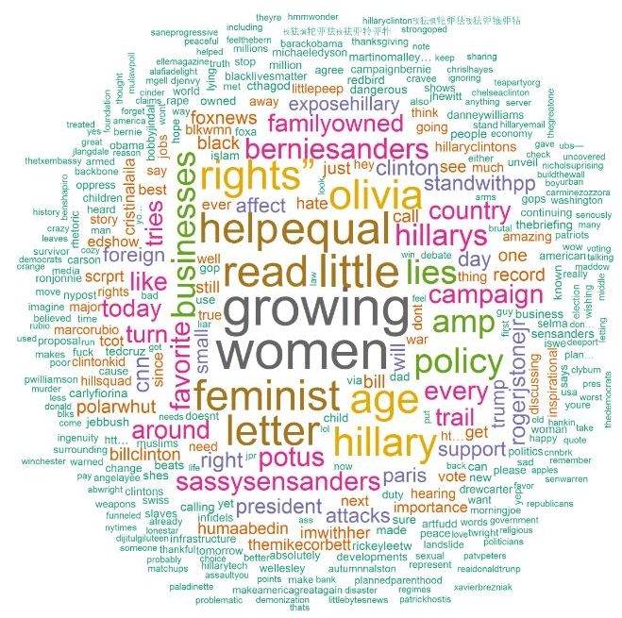

The size of the word determines that how commonly it is being used in the tweets. Bigger the word is, more commonly it is being used. With this one can keep track of what a particular candidate has been thinking and communicating in the recent days.
The code also does a graphical representation of the words used in the tweets of the respective candidates on the basis of their positivity and negativity. It gives us a clear picture of the words used, measured on a scale. This result is also saved into a file on the system shown as below.
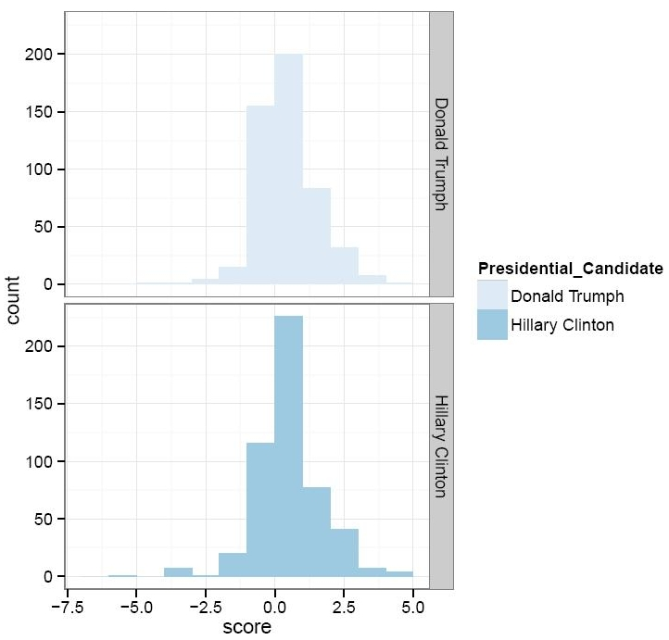

The Y axis shows the count which is the number of words used and the X axis shows the scale of the words being positive or negative (0.0 represents neutral word, -7.5 represents the most negative, 5.0 represents the most positive and respectively).
The final part of the code executes and results in a file being saved on the system representing a “Box Plot”, which becomes the deciding factor among the participating candidates. The box plot (a.k.a. box and whisker diagram) is a standardized way of displaying the distribution of data based on the five number summaries: minimum, first quartile, median, third quartile, and maximum. A box plot comparing two candidates is shown below.
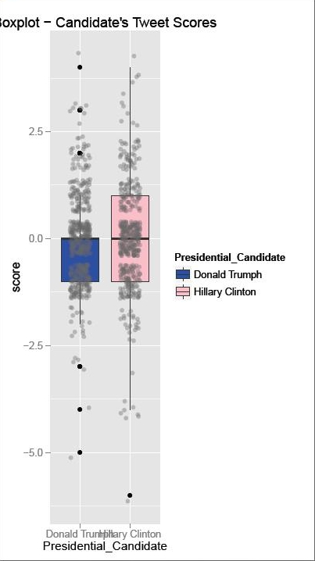
Outliers may be plotted as individual points. Box plots are non-parametric: they display variation in samples of a statistical population without making any assumptions of the underlying statistical distribution. The spacing between the different parts of the box indicates the degree of dispersion (spread) and skewness in the data, and show outliers.

CONCLUSION

Therefore in this paper we have given a brief idea on this word battle by analyzing the tweets of election candidates and by performing operations on their tweets and try to predict which candidate is most likely to win the White house next year.

The output is produced in three forms:
- Word Clouds
- Graphs
- Box Plot

The statistics, graphical data and the processed words helps in prognostication of the probable President based on people’s support on social media.

REFERENCES

- G. Eason, B. Noble, and I.N. Sneddon, “On certain integrals of Lipschitz-Hankel type involving products of Bessel functions,” Phil. Trans. Roy. Soc. London, vol. A247, pp. 529-551, April 1955. (references)

- J. Clerk Maxwell, A Treatise on Electricity and Magnetism, 3rd ed., vol. 2. Oxford: Clarendon, 1892, pp.68-73.

- I.S. Jacobs and C.P. Bean, “Fine particles, thin films and exchange anisotropy,” in Magnetism, vol. III, G.T. Rado and H. Suhl, Eds. New York: Academic, 1963, pp. 271-350.

- K. Elissa, “Title of paper if known,” unpublished.

- R. Nicole, “Title of paper with only first word capitalized,” J. Name Stand. Abbrev., in press.

- Y. Yorozu, M. Hirano, K. Oka, and Y. Tagawa, “Electron spectroscopy studies on magneto-optical media and plastic substrate interface,” IEEE Transl. J. Magn. Japan, vol. 2, pp. 740-741, August 1987 [Digests 9th Annual Conf. Magnetics Japan, p. 301, 1982].

- M. Young, The Technical Writer’s Handbook. Mill Valley, CA: University Science, 1989.

